
ESLBO 7-1E: Quebec City Information

Give a short presentation to your classmates about this city. You can shorten the presentation by adding two of the adjective sentences into one sentence. Include three facts about your city in your presentation.

Quebec City

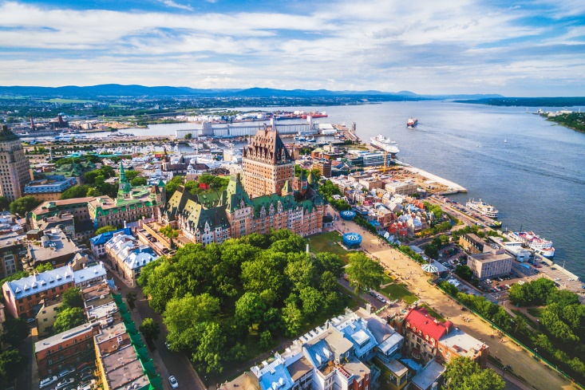

Quebec City is a capital city. Quebec City is the capital city of the province Quebec.

Quebec City is a bilingual city. That means that most people in Quebec City speak more than one language. Many of them speak English and French.

Quebec City is an old, Canadian city. Compared to many European and Asian cities, Quebec City is not old but in Canada it is considered old.

Quebec City is an historic city. Many important battles happened in Quebec City. Now, it is considered the home of the French culture in Canada.

