**ESLBO 7-1E: Toronto Information**

***Give a short presentation to your classmates about this city. You can shorten the presentation by adding two of the adjective sentences into one sentence. Include three facts about your city in your presentation.***

**Toronto**

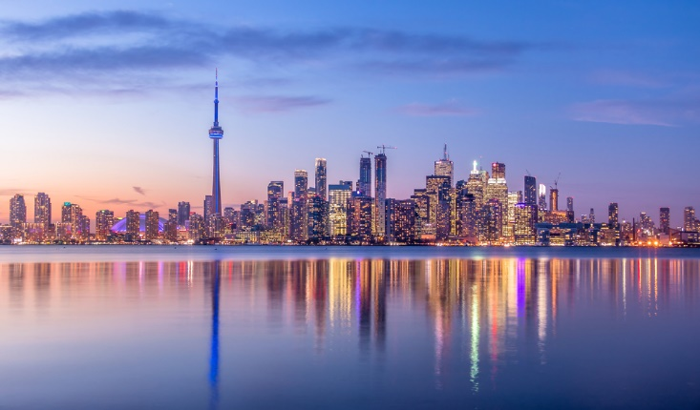

Toronto is a capital city. Toronto is the capital city of the province Ontario.

Toronto is an expensive city. Housing and transportation is considered expensive compared to other cities.

Toronto is an athletic city. Toronto has many popular sports teams, including: Toronto Raptors (basketball), Toronto FC (soccer), Toronto Argos (football), Toronto Blue Jays (baseball) and Toronto Maple Leafs (hockey).

Toronto is a safe city. Toronto has a very low crime rate.

Toronto is a small city. To compare Toronto, Canada is 630.21 km2, while Beijing, China is 16 411 km2.