**ESLBO 7-1E: Vancouver Information**

***Give a short presentation to your classmates about this city. You can shorten the presentation by adding two of the adjective sentences into one sentence. Include three facts about your city in your presentation.***

**Vancouver**

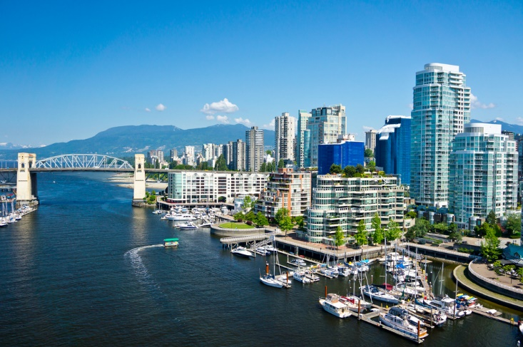

Vancouver is a capital city. Vancouver is the capital city of the province British Columbia.

Vancouver is an expensive city. Housing and transportation is considered expensive compared to other cities.

Vancouver is a coastal city. A coastal city is a city that is located on the edge of the country. Vancouver is on the west coast of Canada.

Vancouver is a warm, Canadian city. In Canada, Vancouver is considered one of the warmest cities.

Vancouver is a diverse city. Vancouver has many different cultures living there.