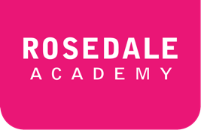**ESLBO 3-2E: Peer Edit Rubric**

***Use this sheet to edit your peers work:***

**Essay Writer’s Name:**

**Peer Editor’s Name:**

|  |  |  |  |  |  |
| --- | --- | --- | --- | --- | --- |
| **Criteria** | **Level 1** | **Level 2** | **Level 3** | **Level 4** | **Feedback** |
| **Grammar and spelling** | The grammar is not used accurately.  Few words are spelled correctly. | The grammar is used somewhat accurately.  Some words are spelled correctly. | The grammar is mostly used accurately.  Most words are spelled  correctly. | The grammar is always used accurately.  All words are spelled correctly |  |
| **Topic and Theme**  Criteria:  The topic is about personal, family or cultural history.  The essay includes a paragraph about the environment.  There are transition words used throughout the essay. | The topic and theme do not meet any of the criteria given. | The topic and theme kind of meet the criteria given. | The topic and theme meet the criteria well. | The topic and theme are present throughout the article. |  |
| **Structure of Essay**  Paragraphs and flow of ideas | The essay is missing paragraphs.  The ideas of the essay do not connect to the topic sentence/thesis statement. | The essay has five unclear paragraphs.  The ideas of the essay loosely connect to the topic sentence/ thesis statement. | The essay has five clear paragraphs.  The ideas of the essay connect to the topic sentence/ thesis statement. | The essay has five well written and clear paragraphs.  The ideas of the essay flow perfectly from the topic sentence/ thesis statement. |  |

**Additional Comments:**