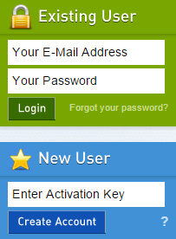
- Create Account
- Visit www.myBlueprint.ca
- Enter Activation Key “rosedaleacademy” and click Create Account
- Have an account? Enter your email/password in the Existing User box
Forgot your password? Click on “Forgot your password?”

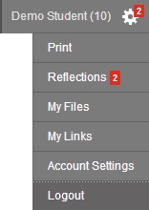
- Link with a Teacher
- You may need to link with your Teacher as part of a class activity
- From your Home Screen, click on the Toolbox and select My Links
- Click Add Teacher, find your teacher and click Send Request

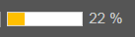
- Complete 100% Progress
- From your Home Screen, mouse over each box and review the requirements
- Click on any box to get started and complete an activity
- Once you complete every activity, your progress tracker will reach 100%
- Each September the tracker will reset and you will have new activities to complete
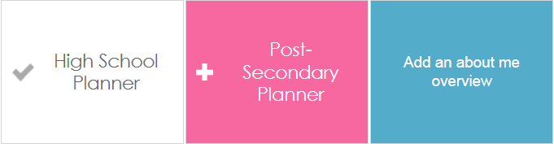

- Build Your Portfolio
- Click on My Portfolio to review your profile
- Click Add in any feature to update the section
- You can share your profile by clicking Share Your Portfolio

