Translation of definitions of MDM4U, Rosedale Academy

Unit 1: Counting and Probability / 计算与可能性

1-1 Organized Counting

The Fundamental Counting Principle / 基本计数原理
If a first action can be performed in ways and a second action can be performed in ways then these two actions can be performed, in this order, in ways.
In general, if a task or process is made up of stages with separate choices, the total number of choices is , where is the number of choices for the first stage, is the number of choices for the second stage, is the number of choices for the third stage, and so on.

如果第一个行为有m种方式去展现，第二种行为有n种方式去展现，那么既有mn种方式去展现这两种行为。
总之，如果一个由不同的阶段组成的任务或者流程有着不同的选择，选择的总数就是m x n x p x…，其中m 是第一阶段选项的数字,n 是第二阶段选项的数字，p 是第三阶段选项的数字以此类推。

Rule of Sum / 加法法则
If one action can be performed in ways and another action can be performed in ways and the first and second action cannot be performed at the same time, then there are ways in which either the first action or the second action can be performed.
In other words, if you can choose from either items of one type or items of another type, then the total number of ways you can choose an item is , which is also known as Additive Counting Principle.

如果一个事件有m种方式展现，另一个事件有n种方式展现，并且这两个事情不能同时发生。所以，有m+n种方式第一种事件或者第二种事件可以执行。
换句话说，如果你可以从一个类型的m个项目或者另一个类型的n个项目中选择，那么你可以选择一个项目的总数是m+n，这也可以被称为加法计数法则。

Factorial Notation ／阶乘
Many counting and probability calculations involve the product of a series of consecutive integers. For example: . To work more easily with such calculations we introduce a new notation called Factorial. Click here to learn in depth about factorials.
For a natural number ,
n! = n x (n-1) x (n-2) x (n-3) x ..... x 3 x 2 x 1
This expression is read as factorial. We denote a factorial as “n!".

许多计数和概率计算都会涉及一系列连续整数的乘积。举个例子：5x4x3x2x1。为了更容易进行这种计算，我们引进了一种称为阶乘的新符号。对于自然数n,一个正整数的阶乘是所有小于及等于该数的正整数的积，并且0的阶乘为1。自然数n的阶乘写作n!
n! = n x (n-1) x (n-2) x (n-3) x ..... x 3 x 2 x 1

1-2 Permutations 排列

Permutation Formula ／排列公式
A permutation of distinct objects or items is an arrangement of all the objects or items in a definite order. The total number of such permutations is denoted by .
There are possible ways of choosing the first item, ways of choosing the second, ways of choosing the third, and so on. Applying the Fundamental Counting Principle, we have
从n个不同元素中每次取出m（1≤m≤n）个不同元素，排成一列，称为从n个元素中取出m个元素的无重复排列或直线排列，简称排列。从n个不同元素中取出m个不同元素的所有不同排列的个数称为排列种数或称排列数，记为P(n,n) 或者 nPn.就是说，n个不同元素全部取出的排列数，等于正整数1到n的连乘积。正整数一到n的连乘积，叫做n的阶乘.

1-3 Pascal’s Triangle and its Applications /帕斯卡三角及其应用

Pascal’s triangle/帕斯卡三角
Pascal’s method for building his triangle is a simple iterative process. In Pascal’s triangle, each term is equal to the sum of the two terms immediately above it. The first and the last terms in each row are both equal to 1 since the only term immediately above them is also a 1.

帕斯卡构建三角形的方法是一个简单的迭代过程。在帕斯卡三角形中，每一项都等于它上面两项的和。每一行的第一项和最后一项都等于1因为它们上面唯一的一项也是1。

Applications/应用

与帕斯卡三角联系最紧密的是二项式乘方展开式的系数规律，即二项式定理。例如在杨辉三角中，第3行的三个数恰好对应着两数和的平方的展开式的每一项的系数，第4行的四个数恰好依次对应两数和的立方的展开式的每一项的系数，即 ，以此类推。
第n行的m个数可表示为C(n-1,m-1)，即为从n-1个不同元素中取m-1个元素的组合数。因此可得出二项式定理的公式为： 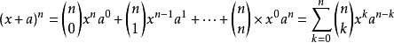

1-4 Venn diagrams and sets/ 维恩图解与集合

Venn Diagram ／维恩图解
A Venn diagram uses overlapping circles or other shapes to illustrate the logical relationships between two or more sets of items. Often, they serve to graphically organize things, highlighting how the items are similar and different.

Venn diagrams, also called Set diagrams or Logic diagrams, are widely used in mathematics, statistics, logic, teaching, linguistics, computer science and business. Many people first encounter them in school as they study math or logic, since Venn diagrams became part of “new math” curricula in the 1960s. These may be simple diagrams involving two or three sets of a few elements, or they may become quite sophisticated, including 3D presentations, as they progress to six or seven sets and beyond. They are used to think through and depict how items relate to each within a particular “universe” or segment. Venn diagrams allow users to visualize data in clear, powerful ways, and therefore are commonly used in presentations and reports. They are closely related to Euler diagrams, which differ by omitting sets if no items exist in them. Venn diagrams show relationships even if a set is empty.

维恩图使用重叠的圆圈或其他形状来说明两个或多个项目集之间的逻辑关系。通常，它们用于图形化地组织事物，突出项目之间的相似和不同之处。

维恩图，又称集合图或逻辑图，广泛应用于数学、统计、逻辑、教学、语言学、计算机科学和商业。自从20世纪60年代维恩图成为“新数学”课程的一部分以来，许多人在学习数学或逻辑时第一次遇到它。这些可能是包含两三组元素的简单图表，也可能变得相当复杂，包括3D演示，因为它们会发展到六组或七组以上。它们被用来思考和描述在一个特定的“宇宙”或部分中，物品是如何与每一个物品相关联的。Venn图允许用户以清晰、强大的方式可视化数据，因此通常用于演示和报告。它们与欧拉图密切相关，如果欧拉图中不存在项，则省略集合。维恩图显示了即使集合是空的关系。

Set／集合
The objects in a set are called its elements or members. When the elements of a set are listed, they are included in brace brackets, { }, and separated by commas.

集合中的对象称为其元素或成员。当列出一个集合的元素时，它们包含在大括号{}中，并以逗号分隔。

Properties of sets /集合的性质
(1). Disjoint Sets:
If two sets have no elements in common, they are called disjoint sets. Also a set with no elements is called the null set or the empty set. It is represented as { } or .
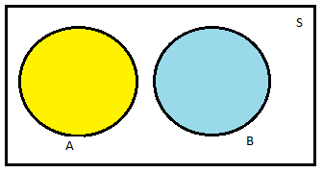
分离集合： 如果两个集合没有共同的元素，则称为不相交集合。此外，如果一个集合里没有元素则称为空集 用{}表示。

(2). Subset:
If all the elements of set are also elements of set , we say set is a subset of set and write , saying is contained in or contains . Therefore, every set is a subset of itself and the null set is a subset of every set.
All the sets which we are interested, in a particular situation, are subsets of the universal set for that situation. We will denote the universal set by .
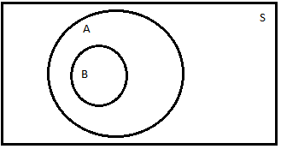
子集：
如果B集合的所有元素也属于集合A，那么我们称集合B是集合A的子集。我们称为集合B属于集合A，或者集合A包含集合B。
此外，所有集合是他本身的子集，空集是所有集合的子集。我们所感兴趣的所有集合在一个特定的情况下，我们用S表示这个情况下的子集。

(3). Complement of a Set:
For a set , the complement of is the set, denoted , containing all the elements of the universal set which are NOT elements of .
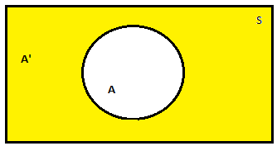
The yellow space above is considered the compliment A'.

补集： 对于一个集合A，A’ 包含在所有元素里不属于A的元素，则A'称为集合A的补集。

(4). Union of Sets:
For two sets and , the union of and is the set, denoted by , containing all the elements of the universal set which are either in a set OR in a set or in both sets.
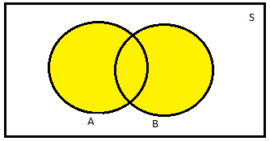
The yellow space above is considered the union.

并集：由所有属于集合A或者集合B所组成的集合称为A与B的并集。

(5). Intersection of Sets:
For two sets and , the intersection of and is the set, denoted by , containing all the elements of the universal set, which are both in set AND in set .
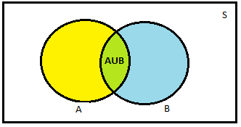
The green space above is considered the intersection.

交集： 由属于集合A并且属于集合B所组成的集合称为集合A与集合B的交集。

(5). Principle of Inclusion and Exclusion for Two Sets:

For sets and , the total number of elements in either or is the number in plus the number in minus the number in both and .
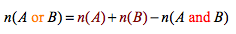
where represents the numbers of elements in a set .
The sets of all elements in either set or set is the union of and . Similarly, the set of all elements in both and is the intersection of and . Therefore, the principle of inclusion and exclusion for two sets can also be stated as:

两个集合的包含与排除原则：
对于集合A与集合B，A或B的元素总数等于A中的元素加上B中的元素减去A和B中的元素数。其中n(x)表示集合X中的元素个数。

在集合里的元素无论是在集合A还是集合B都是A与B的并集啊，同理，在集合里的元素也都是A与B的交集；所以这个原理同样也可以称为。

1-5 Combination／组合
A combination of n (distinct) objects taken r at a time is a selection of r of the n objects without regard to order. The total number of combinations of n objects taken r at a time is denoted by: (n/r) reads as n chose r.
Alternative notations include C(n,r) and nCr.

从n个不同的元素中取出r个元素组成一组, 叫做从n个不同元素中取出r个元素的一个组合。 表示:C(n,r) 。公式为： C(n,r) = n!/r!(n-r)!

1-6 The Binomial Theorem and the General Term

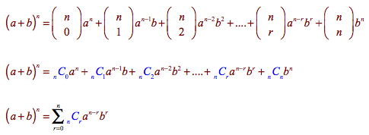
As you might expect from the investigation at the beginning of this learning activity, the coefficients of each term in the expansion of (a + b)^{n} correspond to the terms in row of Pascal's triangle. Thus, you can write these coefficients in combinatorial form.
根据此定理，可以将x+y的任意次幂展开成和的形式
其中每个 为一个称作二项式系数的特定正整数，其等于 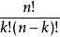 。这个公式也称二项式公式或二项恒等式。使用求和符号，可以把它写作
