Electromagnetic Spectrum:

Radiation is energy that travels and spreads out as it goes-- visible light that comes from a lamp in your house or radio waves that come from a radio station are two types of electromagnetic radiation. Other examples of EM radiation are microwaves, infrared and ultraviolet light, X-rays and gamma rays. Hotter, more energetic objects and events create higher energy radiation than cool objects. Only extremely hot objects or particles moving at very high velocities can create high-energy radiation like X-rays and gamma rays.
Here are the different types of radiation in the EM spectrum, in order from lowest energy to highest:
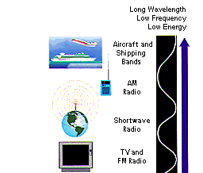 | Radio: yes, this is the same kind of energy that radio stations emit into the air for your boom box to capture and turn into your favorite channels but radio waves are also emitted by other things such as stars and gases in space. You may not be able to dance to what these objects emit, but you can use it to learn what they are made of.
 | Microwaves: they will cook your popcorn in just a few minutes! In space, astronomers use microwaves to learn about the structure of nearby galaxies.
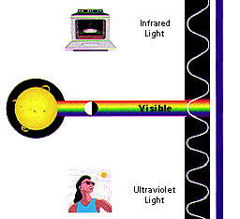 | Infrared: we often think of this as being the same thing as 'heat', because it makes our skin feel warm. In space, IR light maps the dust between stars.  Visible: yes, this is the part that our eyes see. Visible radiation is emitted by everything from fireflies to light bulbs to stars ... also by fast-moving particles hitting other particles. Ultraviolet: we know that the Sun is a source of ultraviolet (or UV) radiation, because it is the UV rays that cause our skin to burn! Stars and other "hot" objects in space emit UV radiation.
 | X-rays: your doctor uses them to look at your bones and your dentist to look at your teeth. Hot gases in the Universe also emit X-rays.
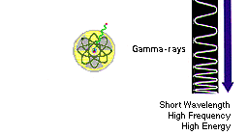 | Gamma rays: radioactive materials (some natural and others made by man in things like nuclear power plants) can emit gamma rays. The biggest gamma-ray generator of all is the Universe! It makes gamma radiation in all kinds of ways.

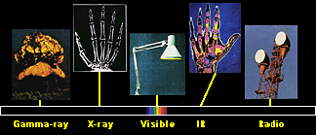
Radio waves, visible light, X-rays, and all the other parts of the electromagnetic spectrum are fundamentally the same thing, electromagnetic radiation.
We may think that radio waves are completely different physical objects or events than gamma rays. They are produced in very different ways, and we detect them in different ways. But are they really different things? The answer is 'no'. Radio waves, visible light, X-rays, and all the other parts of the electromagnetic spectrum are fundamentally the same thing. They are all electromagnetic radiation.
Electromagnetic radiation can be described in terms of a stream of photons, which are mass less particles each traveling in a wave-like pattern and moving at the speed of light. Each photon contains a certain amount (or bundle) of energy, and all electromagnetic radiation consists of these photons. The only difference between the various types of electromagnetic radiation is the amount of energy found in the photons. Radio waves have photons with low energies, microwaves have a little more energy than radio waves, infrared has still more, then visible, ultraviolet, X-rays, and ... the most energetic of all ... gamma-rays.

