Projectile Motions:

Consider again the cannonball launched by a cannon from the top of a very high cliff. Suppose that the cannonball is launched horizontally with no upward angle whatsoever and with an initial speed of 20 m/s. If there were no gravity, the cannonball would continue in motion at 20 m/s in the horizontal direction. Yet in actuality, gravity causes the cannonball to accelerate downwards at a rate of 9.8 m/s/s. This means that the vertical velocity is changing by 9.8 m/s every second.

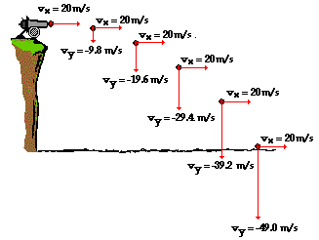

Similarly;

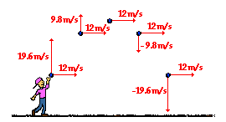

Question:

A football is kicked with an initial velocity of 25 m/s at an angle of 45-degrees with the horizontal. Determine the time of flight, the horizontal displacement, and the peak height of the football.

As indicated in the table, the final x-velocity (v_{fx}) is the same as the initial x-velocity (v_{ix}). This is due to the fact that the horizontal velocity of a projectile is constant; there is no horizontal acceleration. The table also indicates that the final y-velocity (v_{fy}) has the same magnitude and the opposite direction as the initial y-velocity (v_{iy}). This is due to the symmetrical nature of a projectile's trajectory.

The time of flight of the football is 3.61 s, the horizontal displacement of the football is 63.8 m, and the peak height of the football 15.9 m (using time as half).

Question:

A long jumper leaves the ground with an initial velocity of 12 m/s at an angle of 28-degrees above the horizontal. Determine the time of flight, the horizontal distance, and the peak height of the long-jumper.

As a first step, use trigonometric function to determine the initial velocity components:
Horiz: v_{ix} =(12 m/s) • cos (28 deg) =10.6 m/s
Vert: v_{iy} =(12 m/s) • sin (28 deg) = 5.6 m/s

Then set up an x-y table, listing the known information.
Horizontal Info: | Vertical Info:
x = ??? | y = 0.0 m (total); y_{peak} = ???
v_{ix} = 10.6 m/s | v_{iy} = 5.6 m/s  v_{y-peak} = 0 m/s  v_{fy} = -5.6 m/s
a_{x} = 0 m/s/s | a_{y} = -9.8 m/s/s

Use v_{fy} = v_{iy} + a_{y} •t_{total} and vertical info to solve for time; the time of flight is 1.1 seconds (rounded from 1.1497 s).

Now use x = v_{ix} • t + 0.5 • a_{x}• t² to solve for x. Note that a_{x} is 0 m/s/s so the last term on the right side of the equation cancels. By substituting 10.6 m/s for v_{ix} and 1.1 s for t, the x can be found to be 12.2 m (rounded from 12.1817 m)

Finally, use t_{up} = 0.5748 s and the equation y_{peak} = v_{iy} • t_{up} + 0.5 •a_{y} • t_{up}² with vertical info to find the y at the peak. Substituting and solving yields 1.6 m (rounded from 1.6193 m)

