KNOWLEDGE: 20 MARKS

Multiple Choice

- __________ is the process of transferring energy from one of its many forms to another.

- Matter
- Power
- Work
- None of the above

- Rockets are unable to accelerate in space because:

- There is no air in space for the rockets to push off of.
- There is no gravity is in space.
- There is no air resistance in space.
- Nonsense! Rockets do accelerate in space.

- A gun recoils when it is fired. The recoil is the result of action-reaction force pairs. As the gases from the gunpowder explosion expand, the gun pushes the bullet forwards and the bullet pushes the gun backwards. The acceleration of the recoiling gun is

- Greater than the acceleration of the bullet.
- Smaller than the acceleration of the bullet.
- The same size as the acceleration of the bullet.

- Water at the top of Niagara Falls can be said to have energy that can be used to do work as it “falls”. This is an example of

- Thermal energy
- Gravitational potential energy
- Electric potential energy
- None of the above

- If the sum of all the forces acting on a moving object is zero, the object will

- Slow down and stop
- Change the direction of its motion
- Accelerate uniformly
- Continue moving with constant velocity

- A spring scale reads 20N as it pulls a 5.0-kilogram mass across a table. What is the magnitude of the force exerted by the mass on the spring scale?

  - 49 N
  - 5.0 N
  - 4.0 N
  - 20. N

- As an object falls freely, the kinetic energy of the object

  - Decreases
  - Increases
  - Remains the same
  - Does not matter

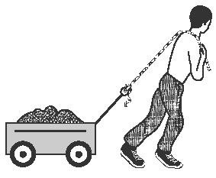
- The diagram below shows a worker using a rope to pull a cart.
The worker’s pull on the handle of the cart can best be described as a force having

- Magnitude, only
- Direction, only
- Both magnitude and direction
- Neither magnitude nor direction

- A 3.0-kilogram block is initially at rest on a frictionless, horizontal surface. The block is moved 8.0 meters in 2.0 seconds by the application of a 12-newton horizontal force. What is the average power developed while moving the block?

- 48 W
- 24 W
- 32 W
- 96 W
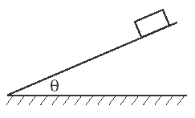
- The diagram below shows a block sliding down a plane inclined at angle Q with the horizontal. As angle Q is increased, the coefficient of kinetic friction between the bottom surface of the block and the surface of the incline will

  - Increases
  - Decreases
  - Remains the same

- An airplane flies with a velocity of 750 Km/hr, 30° south of east. What is the magnitude of the eastward component of the plane’s velocity?

  - 433 km/h
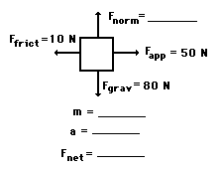
  - 650. km/h
  - 375 km/h

- An applied force of 50 N is used to accelerate an object to the right across a frictional surface. The object encounters 10 N of friction. Use the diagram to determine the normal force, the net force, the mass, and the acceleration of the object.
(Neglect air resistance.) 4 Marks

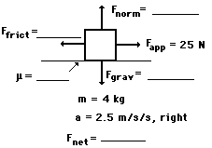
- A rightward force of 25 N is applied to a 4-kg object to move it across a rough surface with a rightward acceleration of 2.5 m/s². Use the diagram to determine the gravitational force, normal force, frictional force, net force, and the coefficient of friction between the object and the surface.
(Neglect air resistance.) 5 Marks

COMMUNICATION: 10 MARKS

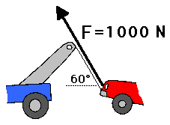
- Consider the tow truck at the right. If the tensional force in the cable is 1000 N and if the cable makes a 60-degree angle with the horizontal, then what is the vertical component of force which contributes to lifting the car off the ground? 4 Mark

- After serenading your girlfriend under her balcony window, you toss a love letter to her wrapped around a small rock (she has a baseball glove and knows how to use it). If the window is 15m away and you toss the rock with a vertical velocity of 13m/s and a horizontal component of 10m/s, how high up the wall was the balcony, assuming she caught the rock without having to reach? 6 Marks

APPLICATION 15 MARKS

- In a demonstration lesson to novice curlers, Sandra Schmirler, the 1996 Canadian Women’s World Curling champion, did the same amount of work on a 20 kg adult’s curling stone as on a 10 kg child’s curling stone.
If she gave the large stone a speed of 2.5m/s, what speed did she give the small stone? 4 Marks

- A boy gives his sister a ride on a sled by exerting a force of 300N [E]. Frictional resistance amounts to 200N. If the sister and the sled have a combined mass of 50 kg , and if the boy starts from rest and pushes for 5 seconds, find the following:

  - Draw the FBD 1 Mark
  - The sled’s acceleration 3 Marks
  - The velocity attained by the sled in 5 seconds 2 Marks
  - The displacement traveled by the sled in 5 seconds 2 Marks

THINKING & INQUIRY 25 MARKS

- A driver approaches an intersection at a speed of 14m/s when the light turns amber. The driver applies the brakes to get the maximum stopping force without skidding. The car has a mass of 1500kg and the force of friction between the tires and the road is 1.1 * 10⁴ N. Ignoring the driver’s reaction time, calculate:

- The maximum deceleration of the car. 2 Marks
- The minimum stopping time. 2 Marks
- The minimum stopping distance. 2 Marks

- A father pulls a child on a sled across the snow. The child and sled have a combined mass of 50 kg. If the snow has a coefficient of kinetic friction of 0.28 and the father applies a force of 200N along the handle of the sled 30 degrees above the horizontal, determine the acceleration of the child and sled?
5 Marks

- Ali is sitting on a cart. The cart and Ali have a mass of 110kg. If they are being pulled with a force of 40N [U20R] and pushed from behind with a force of 44N [D75R], calculate the acceleration of Ali in the horizontal direction. 7 Marks

- A canoe of mass 70 kg with a paddle of mass 55 kg are in a river, If the river’s current exerts a force of 15N [E] while the paddler is paddling with an average force of 22N [N38W]. Find the acceleration of the canoe and paddle. 7 Marks

