
TERM FINAL 2010
Physics Grade 11, University Preparation

Wednesday Dec 8th, 2010 Time: 2 Hours
10am - 12pm

Name : ______________________________

Signature : ______________________________

Marks Obtained : / 65
Knowledge | / 18
Communication | / 12
Application | / 17
Thinking & Inquiry | / 18

Instructions:

Questions are not in order of difficulty. Indicate your choice by circling one letter provided in the question.

- Mark only one answer for each question.
- Questions are all of the same values expect Short Answers and when stated.
- Do NOT use red pen to answer your questions.

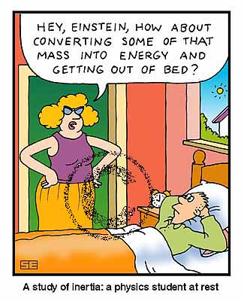

Permitted Materials:

- Blue / Black pens
- Calculator
- Formula Sheet

BEST OF LUCK!

