Physics 11, University Preparation
Unit Test 2 – Forces

Name :________________________ Dec 18th, 2013 (12pm - 1pm)

Communication : / 14 Marks
Knowledge : / 10 Marks
Application : / 8 Marks
Thinking & Inquiry : / 12 Marks
Percentage :

Instructions:
- Questions are NOT in order of difficulty.
- Mark only one answer for each question.
- Do NOT use red pen to answer the questions.

Permitted Materials:
- Blue / Black pen

- Calculator
- Formula Sheet

COMMUNICATION 14 MARKS

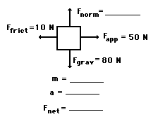

Question 1: An applied force of 50 N is used to accelerate an object to the right across a frictional surface. The object encounters 10 N of friction.

Use the diagram to determine the normal force, the net force, the mass, and the acceleration of the object.
(Neglect air resistance.) 4 Marks

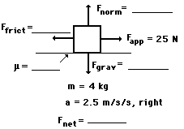
Question 2: A rightward force of 25 N is applied to a 4-kg object to move it across a rough surface with a rightward acceleration of 2.5 m/s².

Use the diagram to determine the gravitational force, normal force, frictional force, net force, and the coefficient of friction between the object and the surface.
(Neglect air resistance.) 5 Marks

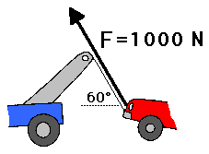

Question 3: Consider the tow truck at the right. If the tensional force in the cable is 1000 N and if the cable makes a 60-degree angle with the horizontal, then what is the vertical component of force which contributes to lifting the car off the ground? 1 Mark

Question 4: Free-body diagrams are diagrams used to show the relative magnitude and direction of all forces acting upon an object in a given situation. Mark all the forces and acceleration acting on this car moving towards west. 4 Marks

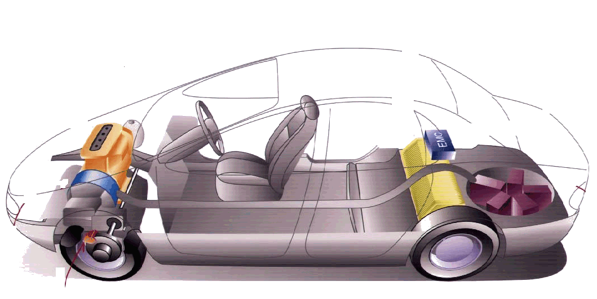

KNOWLEDGE 10 MARKS

Question 5: There are two cars moving at a speed of 50 m/s and 70 m/s with mass of 100 kg and 60 kg respectively. Find the final velocity, of both cars after collision? 3 Marks

Question 6: A 0.112-kg billiard ball moving at 154 cm/s strikes a second billiard ball of the same mass moving in the opposite direction at 46 cm/s. The second billiard ball rebounds and travels at 72 cm/s after the head-on collision. Determine the final velocity of the first billiard ball. 4 Marks

Question 7: Mount Logan in the Yukon is 5959m above sea level and is the highest peak in Canada. Earth’s mass is Kg and Earth’s radius is metres. What would be the difference in the magnitudes of a 55Kg person’s weight, at the top of mountain and that person’s weight at sea level?
(Assume that Earth’s radius, is equal to the distance from Earth’s centre to sea level) 3 Marks

APPLICATION 8 MARKS

Question 8: A boy gives his sister a ride on a sled by exerting a force of 300N [E]. Frictional resistance amounts to 200N. If the sister and the sled have a combined mass of 50 kg, and if the boy starts from rest and pushes for 5 seconds, find the following:

  - Draw the FBD 1 Mark
  - The sled’s acceleration 3 Marks
  - The velocity attained by the sled in 5 seconds 2 Marks
  - The displacement traveled by the sled in 5 seconds 2 Marks

THINKING & INQUIRY 12 MARKS

Question 9: A canoe of mass 70 kg with a paddle of mass 55 kg are in a river, If the river’s current exerts a force of 15N [E] while the paddler is paddling with an average force of 22N [N38W]. Find the acceleration of the canoe and paddle. 6 Marks

Question 10: A box of mass 5.7 kg slides across a floor and comes to a complete stop. If its initial speed was 10 km/hr and = 0.34, find 6 Marks
- The friction acting on the box
- The acceleration of the box
- The distance travelled by the box before stopping
- The time it took to stop

