Unit Test – Motion and Forces Friday Nov 7th, 2008

Name: _______________________ Total Marks: / 60

KNOWLEDGE 12 MARKS

Multiple Choice:

- Study of forces acting on objects at rest is called
  - Statics
  - Dynamics
  - Kinematics
  - Mechanics

- Study of motion by describing and Analysing motions without regard to the forces that are acting on the moving object is called
  - Statics
  - Dynamics
  - Kinematics
  - Mechanics

- Study of the cause of motion or the forces acting on moving objects is called
  - Statics
  - Dynamics
  - Kinematics
  - Mechanics

- Study of the motions of objects and the forces that act on them is called
  - Statics
  - Dynamics
  - Kinematics
  - Mechanics

- _________ are quantities that are specified by a value only and no direction.
  - Scalar Quantities
  - Vector Quantities

- _______ are quantities that are specified by both a magnitude and a direction.
  - Scalar Quantities
  - Vector Quantities

- ______ is a measure of the total travel of the object, regardless of direction.
  - Distance
  - Displacement

- _____ is the net travel of an object as measured from its starting point to its end point in a straight line.
  - Distance
  - Displacement

- _____ is the displacement per unit time, requires direction
  - Average Velocity
  - Speed
  - Instantaneous Velocity
  - None of the above

- _____ is a measurement of velocity done at one specific point and time.
  - Average Velocity
  - Speed
  - Instantaneous Velocity

- While driving, Anna Litical observed a bug striking the windshield of her car. The bug hit the windshield and the windshield hit the bug. Which of the two forces is greater?
    - The force on the bug
    - The force on the windshield
    - The forces are equal in size
    - None of the above

- The acceleration of an object depends inversely on its mass and directly on the unbalanced force applied to it.
  - Newton’s First Law
  - Newton’s Second Law
  - Newton’s Third Law
  - Law of Conservation

COMMUNICATION 10 MARKS

Fill in the Blanks:

- Normal Force is always _____________________ to the surface.

- ______________________ is zero, when the velocity of the object is constant.

- The resultant vector, specified by magnitude and direction, is called __________________

- ______________ is the matter an object composed of and is unchanging regardless of position relative to earth.

- ______________ of an object is changed when an unbalanced force is applied over a given period of time. The resulting change occurs in the direction of force.

- _____________ always opposes the motion or attempted motion of one surface across another surface.

- Free-body diagrams are diagrams used to show the relative magnitude and direction of all forces acting upon an object in a given situation. Mark all the forces and acceleration acting on this car moving towards west. (4 Marks)

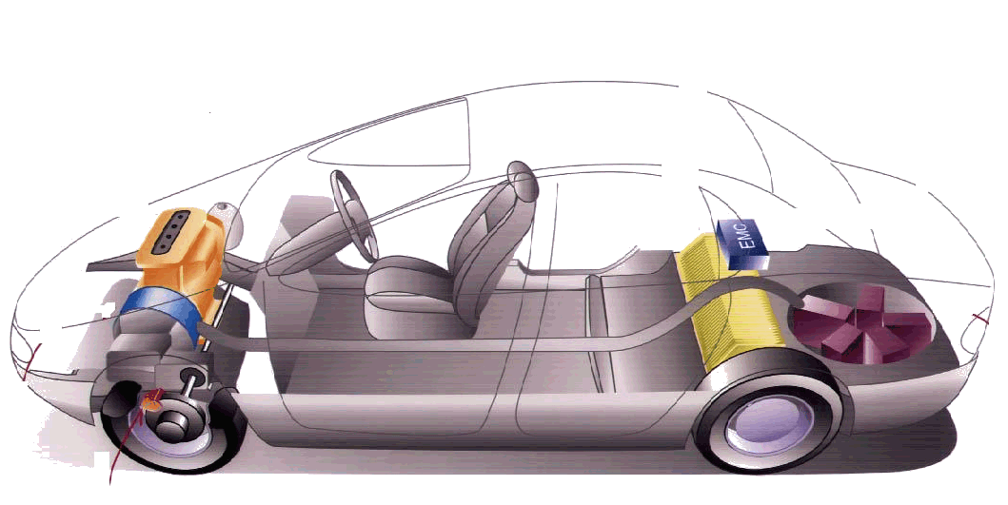

APPLICATION 16 MARKS

Question 20: 5 Marks
A dragster accelerates from rest for a distance of 450m at 14 m/s². A parachute is then used to slow it down to a stop. If the parachute gives the dragster an acceleration of – 7.0 m/s², how far has the dragger travelled before stopping?

Question 21: 5 Marks
A lift truck with rubber tires has a mass of 1640 kg. What is the force of kinetic friction when the lift truck skids on wet concrete with all four tires locked?
(Coefficient of friction is 0.5)

Question 22: 3 Marks
Find the normal force for a crate of mass 670 kg being pulled up by a spring with k = 900 N/r and the spring is stretched 1.55 m. Use a Free Body Diagram.

Question 23: 3 Marks
A rocket blasts off from rest and attains a speed of 45 m/s in 15 seconds. An astronaut has a mass of 57 kg. What is the astronaut’s apparent weight during takeoff?

THINKING / INQUIRY 22 MARKS

Question 24: 9 Marks
A long jumper leaves the ground with an initial velocity of 12 m/s at an angle of 28-degrees above the horizontal. Determine:

- The time of flight
- The horizontal distance
- The peak height of the long-jumper (i.e. The vertical displacement of the projectile when it is halfway through its trajectory – time will be one half of the total time in part a)

Question 25: 7 Marks
A box of mass 5.7 kg slides across a floor and comes to a complete stop. If its initial speed was 10 km/hr and = 0.34, find

- The friction acting on the box
- The acceleration of the box
- The distance travelled by the box before stopping
- The time it took to stop

Question 26: 6 Marks
Find the acceleration of the car moving at 30m/s[E60°N], which then veers off and moves directly east at 25m/s in 2.5 seconds. (Hint: break vectors into components)

