**Pedigrees Handout**

**As you work your way through the pedigrees – tracking inheritance interactive activity, answer the following questions to help you collect the relevant information.**

1. **What is one way that we can infer that a child has inherited two recessive alleles for a trait?**
2. **What is a pedigree?**
3. **Indicate what each of the following symbols represent on a pedigree chart.**

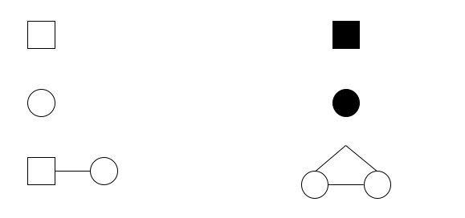

1. **What are roman numerals and Arabic numbers used to denote on a pedigree?**
2. **What is Marfan syndrome? Is the disorder expressed on a dominant or recessive allele?**
3. **What is albinism? What causes it?**
4. **What are some uses of a pedigree chart?**
5. **In what ways are Punnett squares and pedigree charts different?**