**DNA Structure Handout**

**As you work your way through the DNA structure interactive activity, answer the following questions to help you collect the relevant information.**

1. **What are nucleotides made up of? Label the following nucleotide image with the correct parts.**

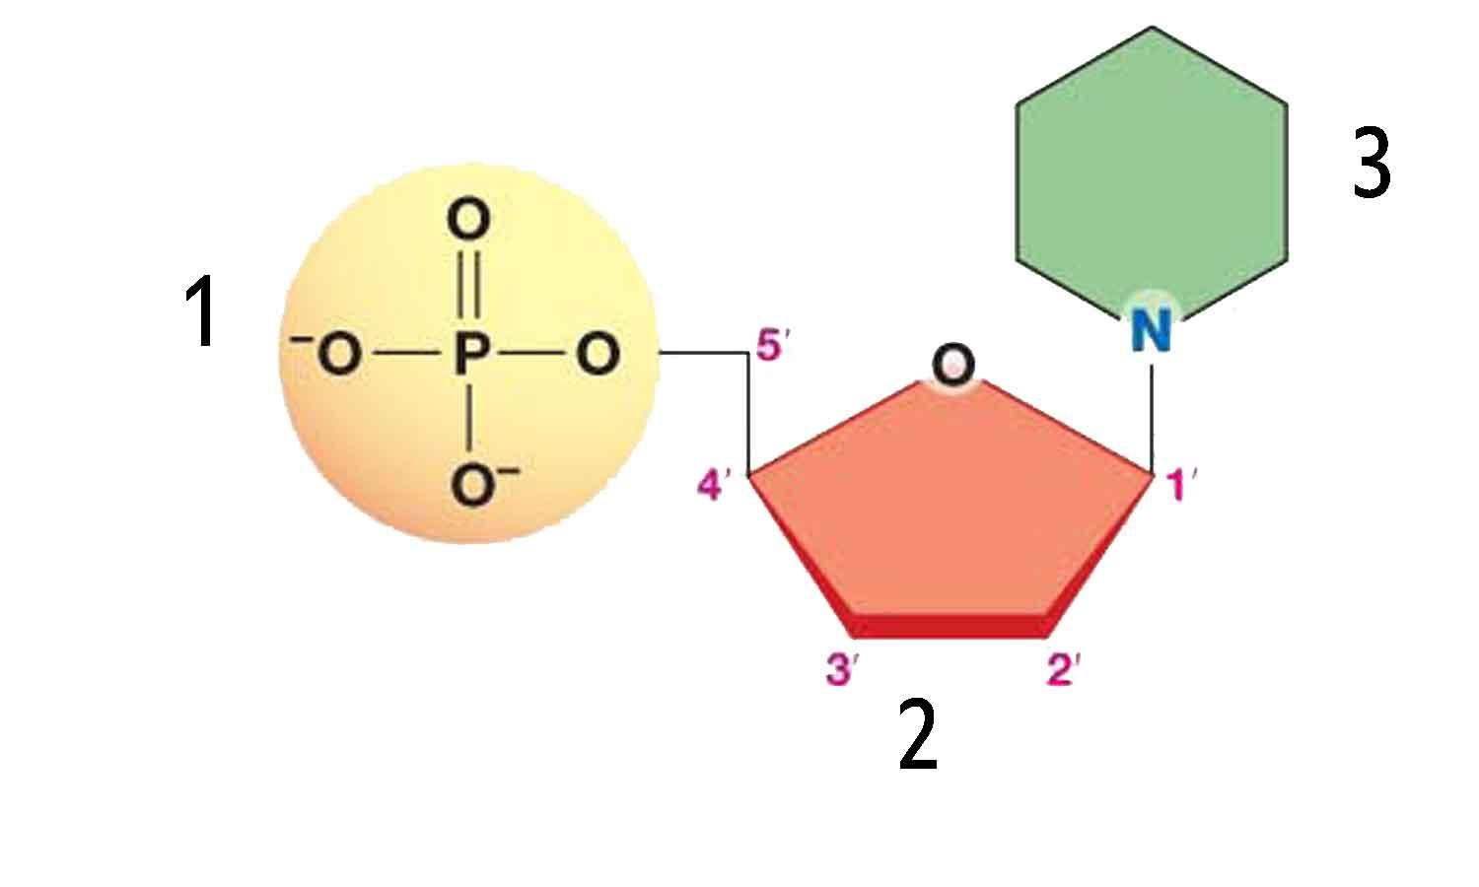

1. **What are the two types of pentose sugars found in nucleotides? What are their properties?**
2. **What are the five types of nitrogenous bases? Which of the two categories do they fall under (hint: purine or pyrimidine)?**
3. **Describe the DNA structure. Label the following diagram.**

**Word bank: Hydrogen bond, 5’ end, 3’ end, phosphodiester bond to 5’ end, phosphodiester bond to 3’ end, backbone**

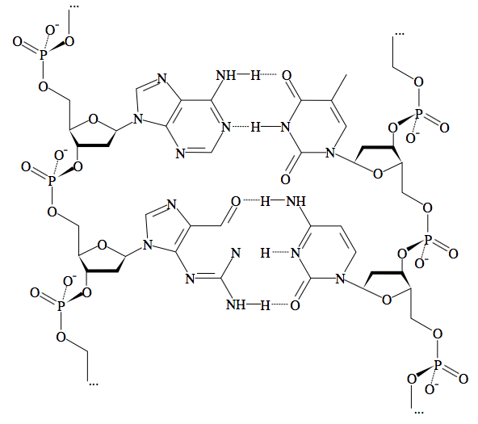

1. **What are the complimentary base pairs? How many hydrogen bonds do they have holding them together?**
2. **Explain the directionality of DNA strands.**