**Enzyme Graphing Worksheet** Theme: *Homeostasis*

Use the graphs located on the right to answer the following questions:

A

Lipase

Sucrase

1. At what pH do the following enzymes work best?
   1. Sucrase:
   2. Trypsin:
2. Where in the digestive system do you think the following

enzymes function?

* 1. Pepsin:
  2. Pancreatic Lipase:
  3. Sucrase:
  4. Trypsin:

B

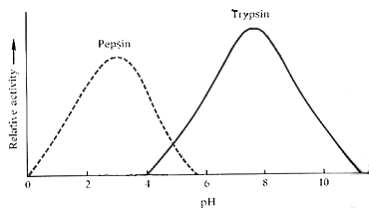

1. Enzymes end in ASE or IN. What substances do you

Think the following enzymes break down?

* 1. Nuclease:
  2. Sucrase:
  3. Lipase:
  4. Pepsin:

1. Predict the reactivity of trypsin at pH 14.

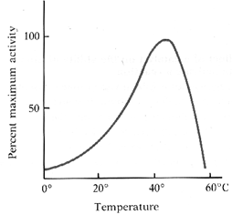

C

1. What is the optimal temperature for the enzyme in graph C?

Where does the enzyme in graph C most likely function?

1. Using graph C:
   1. Explain what happens when hypothermia sets in

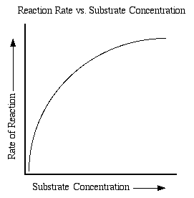(when enzymes get too cold!)

D

* 1. Does the same thing happen when enzymes get too

hot? Why or why not?

1. Explain why graph D levels off. Use enzyme and substrate

in your explanation. Then tell how you could prevent graph

D from leveling off.

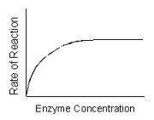

E

1. Why doesn’t it matter if enzymes keep getting added to

graph E? What would it take to increase the rate of enzyme

activity?

**Enzyme Structure Worksheet**  Theme: *Structure Meets Function*

Pick a digestive enzyme. Draw a diagram to show the activity of that digestive enzyme on the appropriate polymer. (ex. Sucrase, Amylase, Trypsin, Lipase, Pepsin)

In your diagram label: enzyme, substrate, active site

Then answer the following questions:

1. Transfer of Energy and Matter: Is an enzyme used up in a chemical reaction?
2. Transfer of Energy and Matter:
   1. How would your diagram be different if the enzyme activity was anabolic instead of catabolic? (Eg. an enzyme to build muscle proteins).
   2. Do digestive enzymes help complete dehydration synthesis or hydrolysis reactions? Explain.
3. Structure Meets Function: What would happen to the enzyme if **denaturation** occurred? Explain two things that might denature your enzyme. Then explain how and why this would affect the function of your enzyme!