**Exploring Applications in Quantum Mechanics Group Activity**

Working in groups of 3-4, read the following article. Then, work together to create a one-page report researching a technological medical application of quantum mechanics. Make sure to address the provided questions in your report. Afterwards, make a 5-8 minute presentation of your findings to the class using either a powerpoint presentation or poster.

**Medical Diagnostic Tools**

The implications and applications of quantum theory are far-reaching and have affected society in many ways. Our understanding of quantum mechanics has been applied to the field of medicine for quite some time. The electron microscope is one example. Electron microscopy uses the wave-like nature of electrons to provide a detailed look at the microscopic world.

Another application is SQUID, a superconducting quantum interference device that interprets brain wave signals and converts them into operating instructions for artificial limbs. Laser eye surgery is a technique that uses a laser to make incisions in the corner for vision correction (**Figure 1**). Positron emission tomography (PET) is used to measure blood flow, oxygen use, and sugar metabolism to help doctors evaluate the health and function of organs and tissues. PET scans detect brain dysfunctions such as tumours, seizures, and memory disorders. Computed tomography (CT) can diagnose many different cancers, such as lung, liver, and pancreatic cancer.

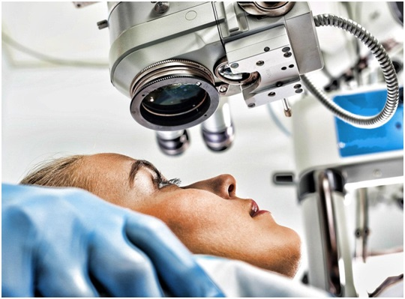

**Figure 1**Laser surgery is commonly used to correct vision.

Many biological processes involve converting energy into forms that can be used in chemical transformations that are quantum mechanical in nature. They involve chemical reactions, light absorption, and the transfer of electrons and protons during photosynthesis and cellular reparation.

**The Application**

The medical field has a long history of developing devices that enhance and assist in disease diagnosis and treatment. Sophisticated and well-funded medical research and development laboratories use the latest scientific discoveries to improve existing technology and design new tools.

**Your Goal**

To identify and describe a technological advance in medicine that uses applications of quantum mechanics.

**Research**

Choose a technological medical application of quantum mechanics. Some examples are CT scans, PET scans, lasers for eye surgery, laser scalpels, UV light sterilizers, quantum dots used in cancer therapy, and SQUIDs.

Use the Internet and other sources to gather specific details related to how the technology operates due to our understanding of the quantum world. Use the following points as a guide:

* Trace the history of the development of the technology
* Identify potential problems or negative impacts on the environment that might arise from this technology
* Determine the advantages that the technology has over its predecessors
* Identify the core science in the operation of the technology
* Determine whether the technology is still being improved or tested
* Determine the social and financial costs associated with the technology. Is it accessible to everyone?

**Summarize**

Use the following questions to summarize your research:

* How was the device benefited the medical field?
* How has quantum mechanics provided practical applications to medical technology?
* What are the major differences between your application and its preceding models?
* What are the advantages that this technology has over its predecessors?
* What are the disadvantages of the technology?
* Summarize the impacts of the technology on society, the economy, and the environment

**Communicate**

Your presentation should convey the advantages and disadvantages of the technology, the quantum nature of the technology, the connection between science and technology, and the larger effects - both positive and negative - of the technology on society and on the environment.

*Adapted from Nelson University Preparation - Physics 12.*