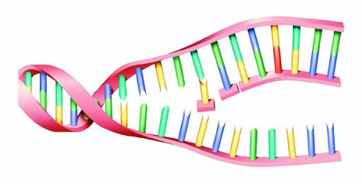
NAME __________________________________ Mutations Worksheet

(staff.fcps.net/einman/biology/MutationsWS.doc) Deletion, Insertion & Substitution

There are several types of mutation:
- DELETION (a base is lost/deleted)
- INSERTION (an extra base is added/inserted)
--- Deletion & insertion may cause what’s called a FRAMESHIFT mutation, meaning the reading “frame" changes, thus changing the amino acid sequence from this point forward
- SUBSTITUTION (one base is substituted for another)
--- If a substitution changes the amino acid, it’s called a MISSENSE mutation
--- If a substitution does not change the amino acid, it’s called a SILENT mutation
--- If a substitution changes the amino acid to a “stop,” it’s called a NONSENSE mutation

Complete the boxes below. Classify each as Deletion, Insertion or Substitution AND as either
frameshift, missense, silent or nonsense (Hint: Deletion & Insertion will always be frameshift).

Original DNA Sequence: T A C A C C T T G G C G A C G A C T …
mRNA Sequence:
Amino Acid Sequence:

Mutated DNA Sequence #1 T A C A T C T T G G C G A C G A C T …
What’s the mRNA sequence? (Circle the change)
What will be the amino acid sequence?
Will there likely be effects? What type of mutation is this? ________________________________

Mutated DNA Sequence #2 T A C G A C C T T G G C G A C G A C T …
What’s the mRNA sequence? (Circle the change)
What will be the amino acid sequence?
Will there likely be effects? What type of mutation is this? ________________________________

Mutated DNA Sequence #3 T A C A C C T T A G C G A C G A C T …
What’s the mRNA sequence? (Circle the change)
What will be the amino acid sequence?
Will there likely be effects? What type of mutation is this? ________________________________

Mutated DNA Sequence #4 T A C A C C T T G G C G A C T A C T …
What’s the mRNA sequence? (Circle the change)
What will be the amino acid sequence?
Will there likely be effects? What type of mutation is this? _________________________________

Original DNA Sequence: T A C A C C T T G G C G A C G A C T …
mRNA Sequence:
Amino Acid Sequence:

Mutated DNA Sequence #5 T A C A C C T T G G G A C G A C T …
What’s the mRNA sequence? (Circle the change)
What will be the amino acid sequence?
Will there likely be effects? What type of mutation is this? _________________________________

- Which type of mutation is responsible for new variations of a trait?
- Which type of mutation does not result in an abnormal amino acid sequence?
- Which type of mutation stops the translation of an mRNA molecule? ______________________________________
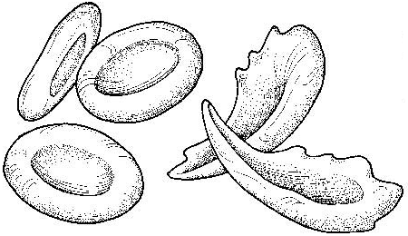
Sickle Cell Anemia

Sickle cell anemia is the result of a type of mutation in the gene that codes for part of the hemoglobin molecule. Recall that hemoglobin carries oxygen in your red bloods cells. The mutation causes these red blood cells to become stiff & sickle-shaped when they release their oxygen. The sickled cells tend to get stuck in blood vessels, causing pain and increased risk of stroke, blindness, damage to the heart & lungs, and other conditions.
--- Analyze the DNA strands below to determine what amino acid is changed AND what type of mutation occurred

Normal hemoglobin DNA C A C G T A G A C T G A G G A C T C …

Normal hemoglobin mRNA

Normal hemoglobin AA sequence

--------------------------------------------------------------------------------------------------------------------------------

Sickle cell hemoglobin DNA C A C G T A G A C T G A G G A C A C …

Sickle cell hemoglobin mRNA

Sickle cell hemoglobin AA sequence

- What type of mutation is this? Please explain why.

------------------------------------------------------------------------------------------------------------------------------------------------------------

