**SBI4U - Photosynthesis Worksheet**

**Instructions:** Use the following questions to help guide and organize your understanding of photosynthesis.

1. What is the overall reaction for photosynthesis?
2. How does this compare to the overall reaction for cellular respiration?
3. Where does the energy for photosynthesis come from?
4. What plant pigments are involved in photosynthesis?
5. Explain why chlorophyll appears green to us in terms of what happens to different wavelengths of light that strike a chlorophyll molecule.
6. Which colors of light are most effective for photosynthesis? Explain why.
7. In what organelle of a plant cell does photosynthesis take place?
8. What are the two stages of photosynthesis?
9. In which part of the chloroplast does each stage occur?
10. What happens to water molecules in the light reactions?
11. What photosynthesis waste product is formed in the light reactions?
12. What two products of the light reactions are used up in the Calvin cycle?
13. What happens to carbon dioxide molecules in the Calvin cycle reactions?
14. How can cells store the sugar that is produced in photosynthesis?
15. Label the diagram below to summarize the two stages of photosynthesis. Use the word bank below the diagram to fill in the blanks.

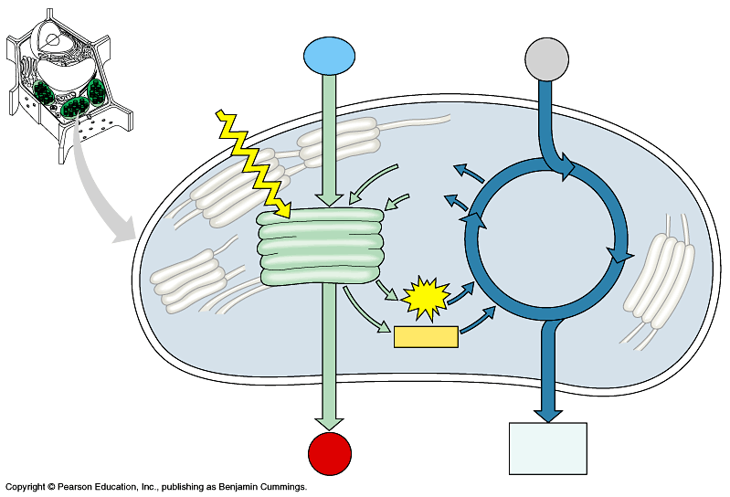

1.

2.

3.

5.

6.

11.

7.

_ 8.

9.

10.__

13.

14.

4.

12.

4. _____

12. _______

Word list:

thylakoids Calvin cycle CO2  NADP+

granum light NADPH O2

stroma H2O ATP ADP + P

light reactions sugar