Transcription and Translation Practice Worksheet
For each of the following sequences, fill in either the DNA, the mRNA sequence, the tRNA anticodons, or the amino acid sequences that have been left blank. If several sequences might work choose any one. Use page 338 in your textbook.

- DNA ___
mRNA A U G A C U A G C U G G G G G U A U U A C U U U U A G
tRNA ___
AA ___

2. DNA T A C C G C T C C G C C G T C G A C A A T A C C A C T
mRNA _
tRNA _
AA _

- DNA __
mRNA __
tRNA U A C C A C C C C C G U A U G G C U G G G A A U A U C
AA __

- DNA
mRNA
tRNA
AA MET ARG GLY PHE PHE MET VAL GLY (STOP)

5. DNA T A C A T G
mRNA U G U G A U
tRNA C U C U U G A U U
AA ALA PRO

- What are the three differences between RNA and DNA?

7. Where is DNA found in the cell?
Where is RNA found in the cell(2 places)?
8. Fill in the below table:
Type of RNA | Function | Basic drawing

- Draw an mRNA strand that is complementary to the DNA strand AATTGC. Circle a nucleotide.

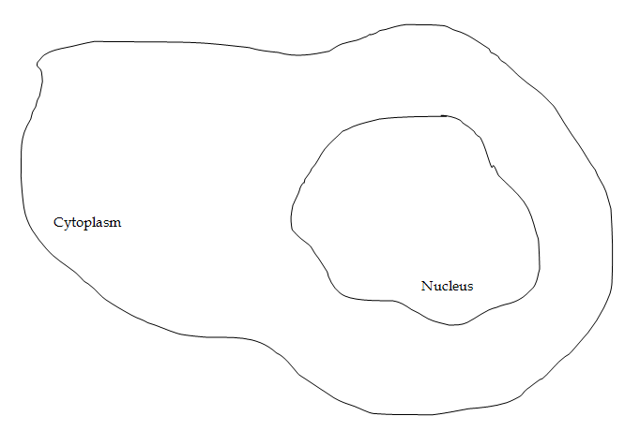
10. Below is a drawing of a cell. Show where transcription and translation are occurring make sure to label the DNA and the RNA (all three types!):

