**ESLBO Unit Test A – ANSWER KEY**

Course: ESLBO Unit Test A Student Name: ­­­­

**Be sure to check your work before submitting your test. Do not leave any questions blank.**

**Each question will be graded according to the achievement chart.**

K – Knowledge and Understanding (This category measures how much you know about a topic and your vocabulary.)

T – Thinking (This category measures how you use information when answering a question. Are you thinking about the question, planning your response, and giving answers from many different perspectives?)

C – Communication (This category measures how you communicate your ideas, both orally and in writing. Do you use proper grammar and writing conventions?)

A – Application (This category measures your ability to apply what you have learned in this course to your own life and in other new situations. It also includes your ability to relate to knowledge from sources outside the course.)

**Follow the grading system when answering questions. For example, if a question is worth two marks, you will be required to have at least two points.**

**Write in full sentences where necessary and explain your ideas with as much information as you can.**

Knowledge/Understanding K : /26

Thinking T : /4

Communication C : /10

Application A : /10

Total Grade : /50

***Part A: Reading – 10 marks (10 minutes) K- /8, T- /2***

My name is Sarah Jenkins. I live in a city called Richmond Hill, which is next to Toronto. I’m a student at Millbrook Middle School. My school is close to my house, so I can walk to school every day with my older sister. My younger brother does not walk with us. He goes to Sussex Elementary School.

I’m 12 years old, and my older sister Emily is 13 years old. We are good friends, but sometimes we fight. I am taller and stronger than my sister, so I can do a lot of things that she can’t do. I can ride my bike by myself, but she can’t ride a bike! That’s not because I’m taller. It’s because I’m better at sports. I can run faster than Emily can, but she can swim better than I can. I can play basketball better than she can, but Emily is better at school than I am. She is really good at math and science. I am really good at gym class and lunch! We walk to school together every day, even when we are fighting. I love my sister, and I love being better at sports than my sister.

1. *Answer the following questions*
   1. Emily (1 mark)
   2. Sarah (1 mark)
   3. Emily (1 mark)
   4. Emily (1 mark)
   5. He goes to a different school (2 marks)
   6. Sarah is better at sports (2 marks)
   7. ANSWERS MAY VARY (2 marks – Thinking)

***Part B: Vocabulary - 10 marks (10 minutes) K- /10***

|  |  |
| --- | --- |
|  | ***Hit a ball*** |
| ***Go fishing*** |
| ***Play badminton*** |
| ***Play table tennis*** |
| ***Run a kilometre*** |
|  | ***Throw a football*** |
| ***Arctic*** |
| ***Countryside*** |
| ***Forest*** |
| ***Sea*** |

***Part C: Grammar - 10 marks (10 minutes) A- /10***

***Think about things that you can do and things you can’t do.***

***Use the vocabulary words in Part B and write 4 sentences using can or can’t.***

1. ANSWERS MAY VARY
2. ANSWERS MAY VARY
3. ANSWERS MAY VARY
4. ANSWERS MAY VARY

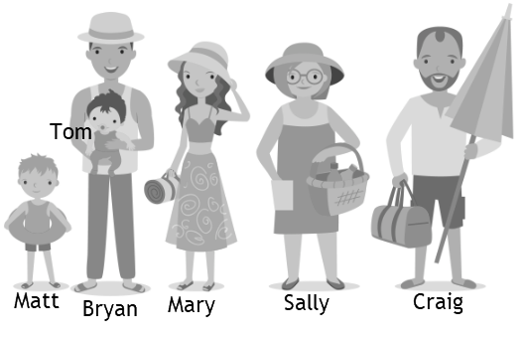

***Look at the people in the picture.***

***Write 3 comparative sentences and 3 superlative sentences:***

1. ANSWERS MAY VARY
2. ANSWERS MAY VARY
3. ANSWERS MAY VARY
4. ANSWERS MAY VARY
5. ANSWERS MAY VARY
6. ANSWERS MAY VARY

***Part D: Writing 10 marks (20 minutes) C- /10***

***Write a paragraph about a town or city you’ve visited.***

***First, use the sandwich organizers. Then, write your paragraph.***

* ***Write 8-10 sentences***
* ***Use one comparative and one superlative***
* ***Use the vocabulary you have learned in ESLBO Units 1 and 2***

***Part E: Listening (10 minutes) K- /8, T- /2***

Listen and answer the questions.

1. Why are dogs helpful at airports? (1 mark) ***Sense of smell***
2. What kind of things do they find at airports? (1 mark) ***Meat and plants***
3. What are two other jobs that dogs do? (2 marks) ***Find missing people; help with sheep and cows on farms***
4. What are two other animals that people ride? (2 marks) ***Elephants and camels***
5. What job do cats do? (1 mark) ***Catch mice***
6. In what country can you rent a cat? (1 mark) ***Japan***
7. Can you think of any other jobs that animals do? (2 marks – Thinking) ***ANSWERS MAY VARY***