**ESLAO Carnival Lesson 2: Worksheet**

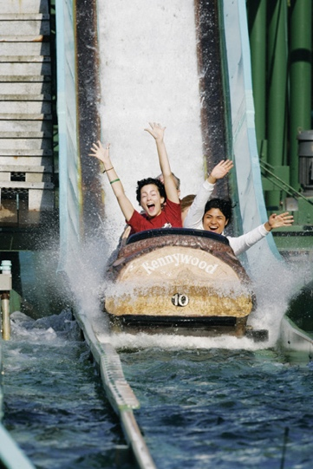**Log Ride:** choose one of your classmates and circle their choice to ride the log ride or not. Then write down one or two words to explain why they want to ride or not.

Want to Ride

(circle one)

Do not want to Ride

**Teacup Ride:** choose one of your classmates and circle whether they liked the teacup ride or not. Then write down some of the words they used to explain why they liked or did not like the ride.

Like the ride

Do not like the ride

(Circle one)