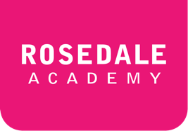**ESLCO 1-1B: Chatting at the Conference**

|  |  |  |
| --- | --- | --- |
| **New Phrases:** | | |
| * By the way,… * Most people just call me… | * …, isn’t it? * look forward to… |  |

**Check Your Understanding**

*Complete each sentence with a phrase from the group above.*

|  |  |
| --- | --- |
| 1. | I ______________________ watching the session on Climate Change. |
| 2. | Jane has the notes for our presentation. ________________ did you bring your computer? |
| 3. | The session on Africa is the most interesting ________________ |
| 4. | “Are you Kevin?” “Yes, ________________________ Kev. |
| 5. | Lunch is at 12:00 _________________ |
| 6. | We ____________________ hearing you at session #4 about Europe. |
| 7. | Thank you for the tickets. ___________________ do you know where I can buy a drink? |

**New Vocabulary**

*Translate the word and write one sentence using the each new word in 1-1B and 1-1C.*

|  |  |  |  |
| --- | --- | --- | --- |
| Vocabulary | Translation |  | Your Sentence |
| conference |  |  |  |
| permit |  |  |  |
| disturb |  |  |  |
| participant |  |  |  |
| interfere |  |  |  |
| vegetarian |  |  |  |
| restriction |  |  |  |
| immigration |  |  |  |
| fisheries |  |  |  |
| debate |  |  |  |