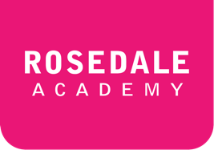**ESLCO 1-2A: Etiquette Vocabulary**

**New Vocabulary**

*Translate the word and write one sentence using the each new word in 1-2A.*

|  |  |  |  |
| --- | --- | --- | --- |
| Vocabulary | Translation |  | Your Sentence |
| etiquette |  |  |  |
| table manners |  |  |  |
| dress code |  |  |  |
| punctual / punctuality |  |  |  |
| personal space |  |  |  |
| taboo |  |  |  |
| customary |  |  |  |

**Check Your Understanding**

*Complete each sentence with the vocabulary words above.*

|  |  |
| --- | --- |
| 1. | The school that I go to has a ______________________. Students have to wear the proper clothes for class |
| 2. | When you go for dinner at a fancy restaurant, it is important to have good ____________________. You don’t want to be rude by mistake. |
| 3. | It is a __________________ to talk about religion at the dinner table in some countries. People will be very upset if you do. |
| 4. | On the subway in Japan, South Korea and China, you likely will not a lot of ______________________________________. |
| 5. | It is ________________________ to take off your shoes when entering a person’s home in some countries. |
| 6. | Being ________________________ is not important in some South American and southern European countries. |
| 7. | Knowing the correct ___________________ when you go to a meeting, restaurant or other situation can help you avoid being rude by mistake. |