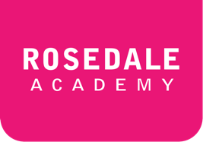**ESLCO 4-2C: The Gold Rush**

*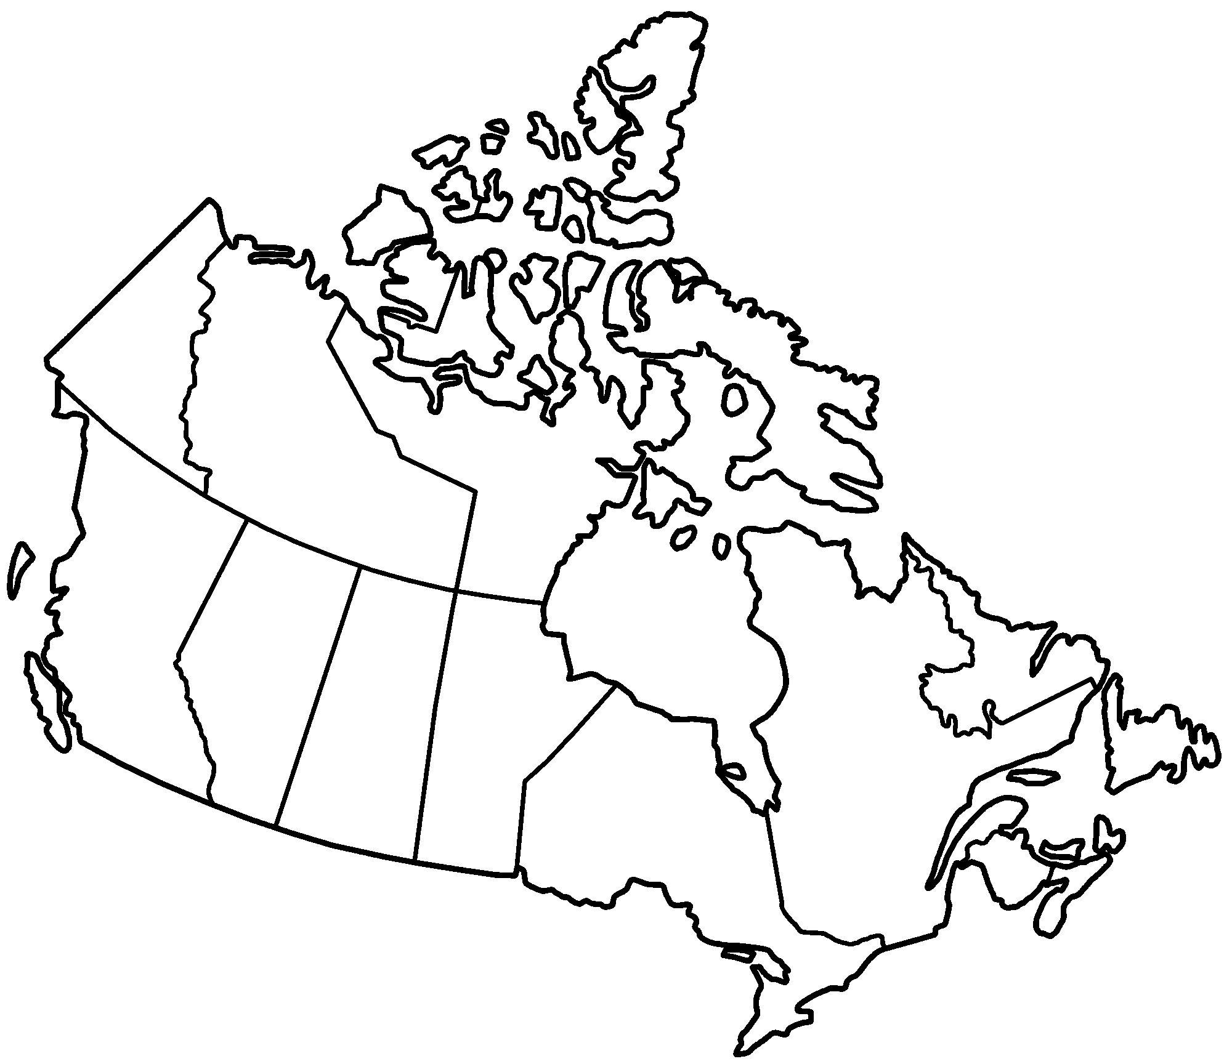***Check your understanding**

*As you read the gold rush reading, complete the questions below.*

***1.*** *Color in the areas on the map where the gold rush happened in Canada.*

***2.*** *What were two ways that people traveled to the goldfields?*

|  |  |
| --- | --- |
| 1. |  |
| 2. |  |

***3.*** *What were some of the challenges that you imagine people had going to the gold fields? (Imagine possible difficulties)*

|  |  |
| --- | --- |
|  |  |
|  |  |
|  |  |
|  |  |

**New Vocabulary**

*Translate the words from the gold rush reading. Add them to the sheet below*

|  |  |  |  |  |  |  |  |
| --- | --- | --- | --- | --- | --- | --- | --- |
|  | Vocabulary |  | Translation |  | Vocabulary |  | Translation |
|  | bonanza |  |  |  | frozen |  |  |
|  | mountainous |  |  |  | turn back |  |  |
|  | railway |  |  |  | give up |  |  |
|  | flows |  |  |  |  |  |  |
|  |

**Create a sentence**

*Create two sentences using the new vocabulary you learned in the reading.*

|  |
| --- |
|  |
|  |