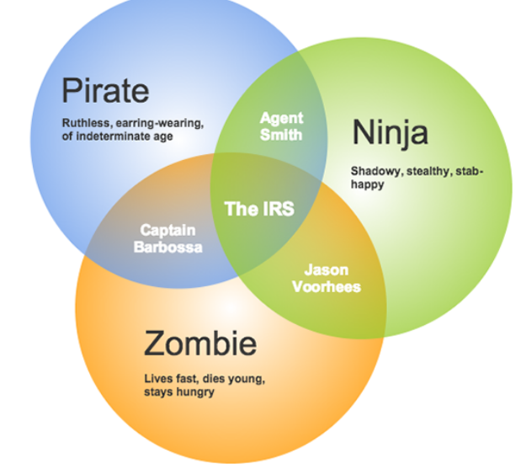
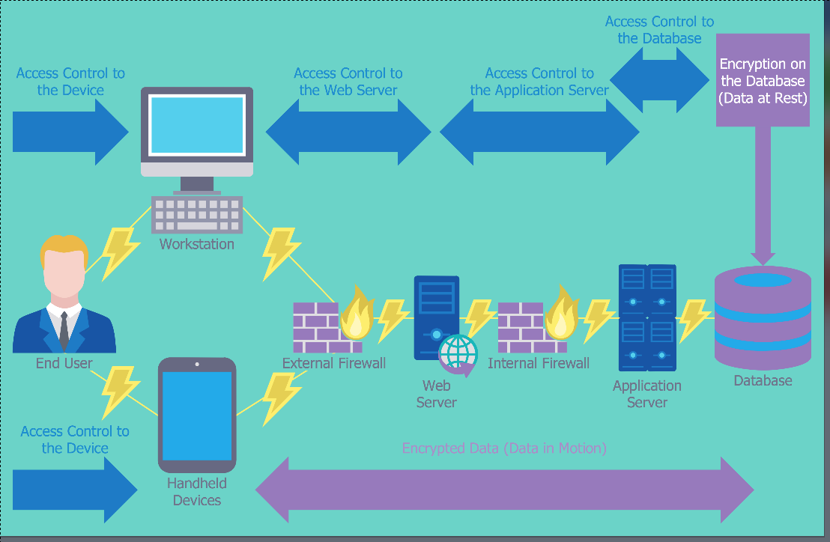
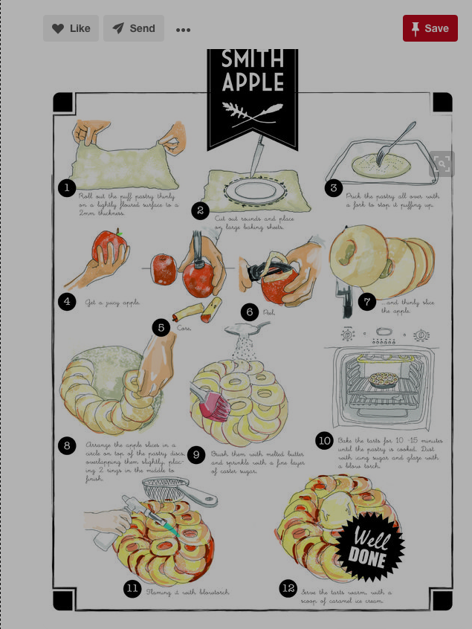
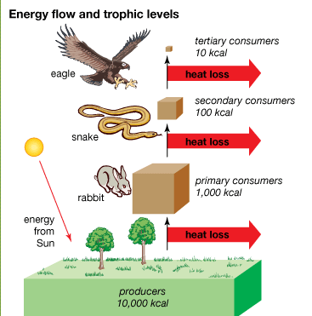
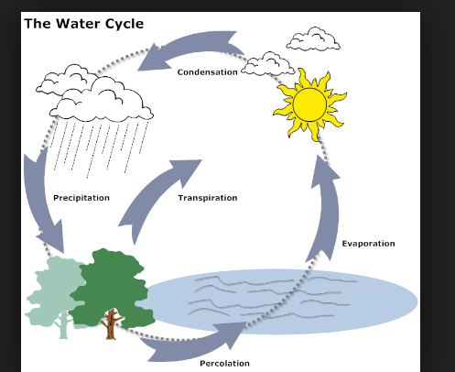
Extend Resource Package
ESLCO

Unit 3 Lesson 4
Resource 1
Venn Diagram: https://www.gliffy.com/blog/2015/12/03/how-to-draw-a-venn-diagram/
Network Security devices: Diagram. http://www.conceptdraw.com/examples/examples-of-software-and-hardware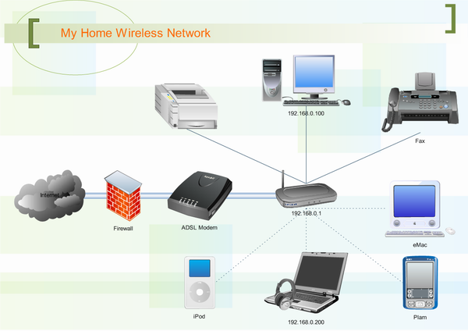
Venn diagram
Venn

Student Grades: Pie chart. https://www.mathsisfun.com/data/pie-charts.html

Resource 1

Resource 1:
Water Cycle: https://www.smartdraw.com/biology-diagram/examples/water-cycle-diagram
Tropical Energy Levels: http://kids.britannica.com/comptons/art-90132/The-amount-of-energy-at-each-trophic-level-decreases-as

