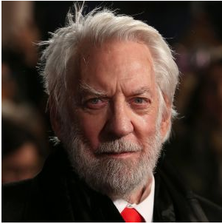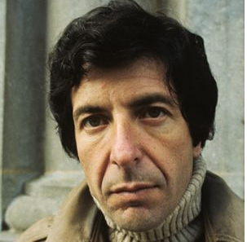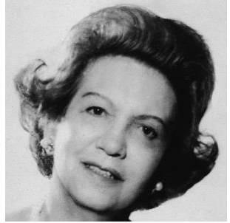

**Extend Resource Package**

**ESLCO**

**Unit 4 Lesson 4**

Known for:

Hockey Player who is the youngest Capitan of a NHL team.

# Donald Sutherland

Known for:

Being a Film Actor

# Sidney Crosby

# Elizabeth Arden

# Leonard Cohen

Known for:

Being a poet, songwriter, and singer

# Elizabeth Arden

Known for:

Her Cosmetics Business

Resource 1:

Reference: pictures. http://www.biography.com/people/

1. The birth and death date of the person?

1. Important event that happened to them?

3. Famous story that tell about their life or character?

1. What are they famous for doing?

Famous Canadian Research Questions

Resource 2



Student Grades: Pie chart. https://www.mathsisfun.com/data/pie-charts.html