ESLAO –Adventure 9 Worksheet

The “BB” Sounds:
Fill in the correct word that has a “BB” sound.


These are ______________________.

Where can you find them?

_____________________________________________________________________.
This is ______________________.

Where can you find it?

_____________________________________________________________________.


Writing a sentence:
Write a short sentence describing the picture.

_________________________________________________________

_________________________________________________________

_________________________________________________

What is that sound? Circle the sound during the lesson!
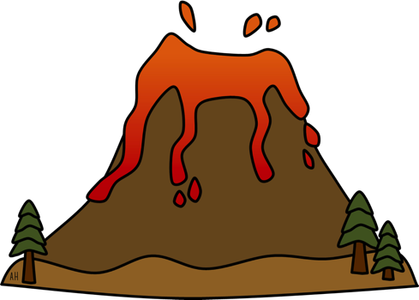

The sound is a ___________________________.

